**Uber Data Analytics Dashboard – Business Insights (Power BI)**

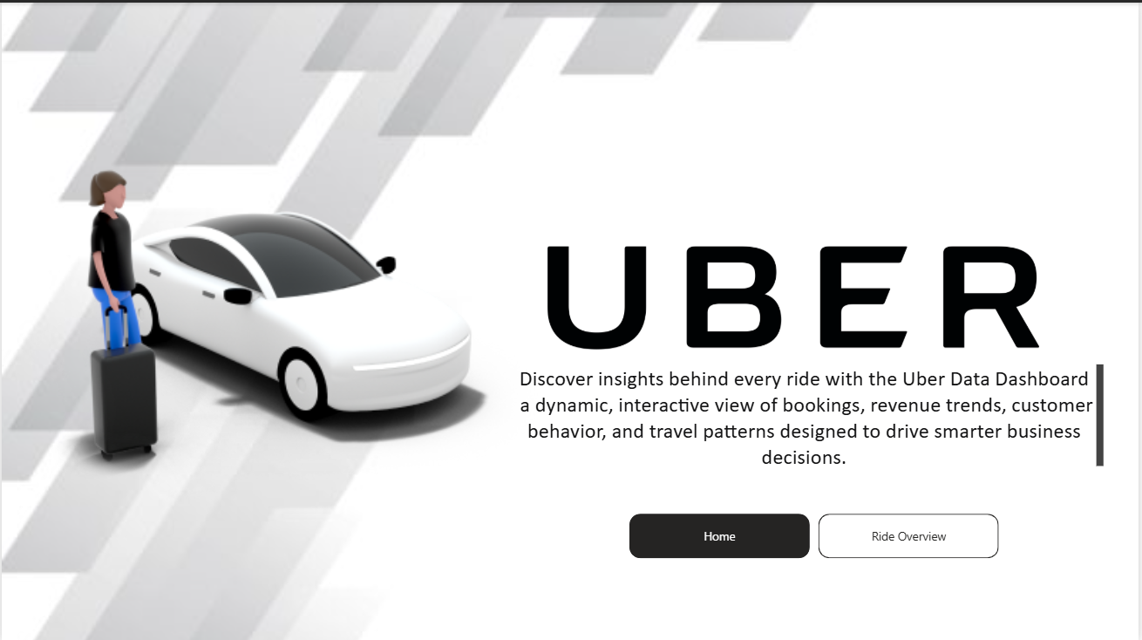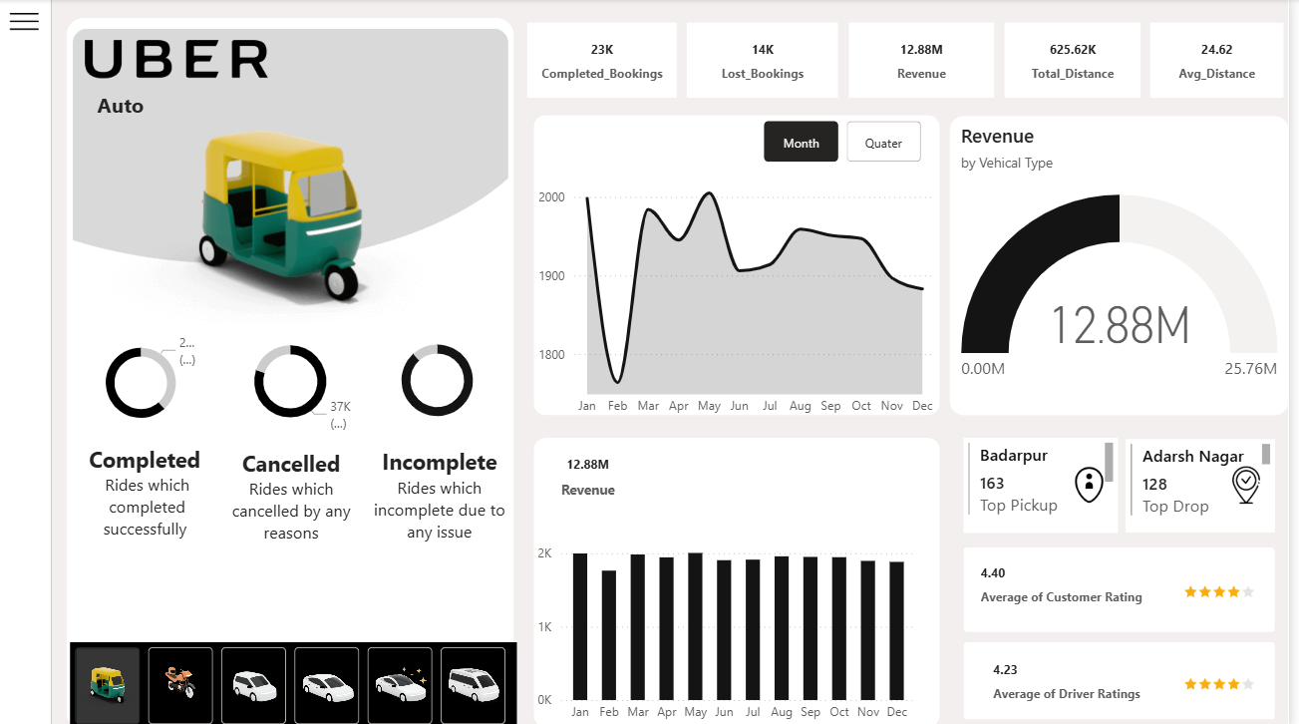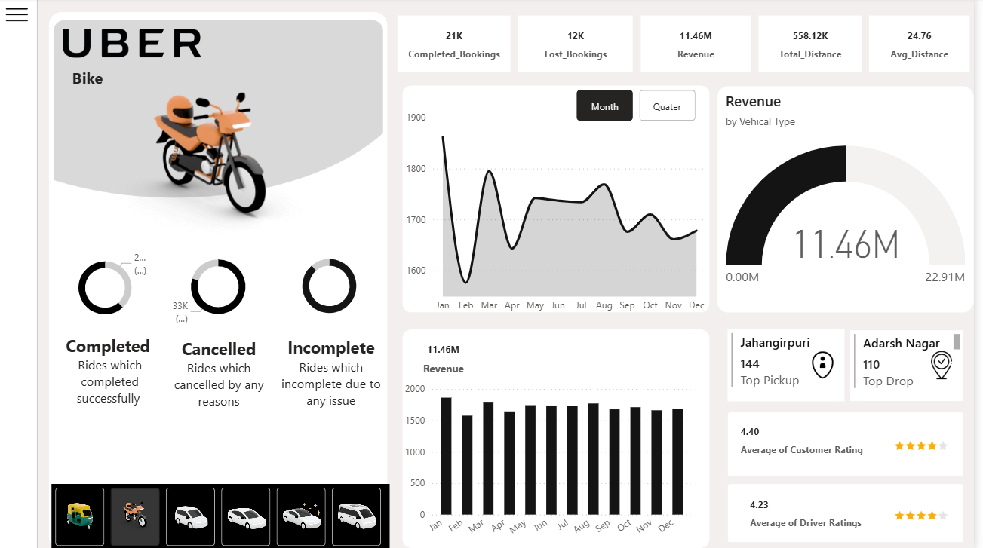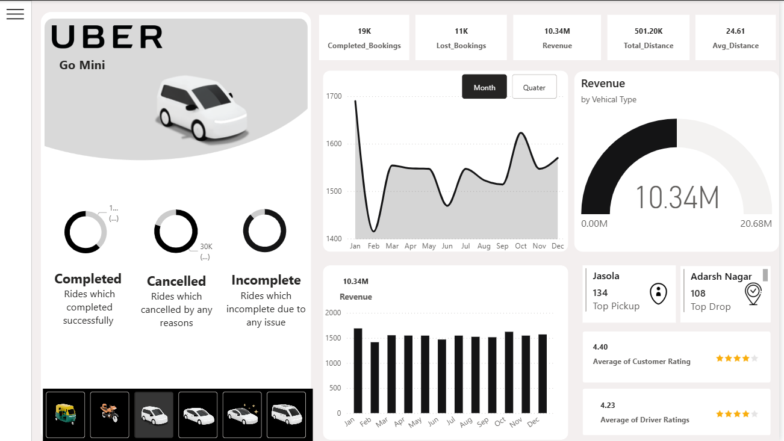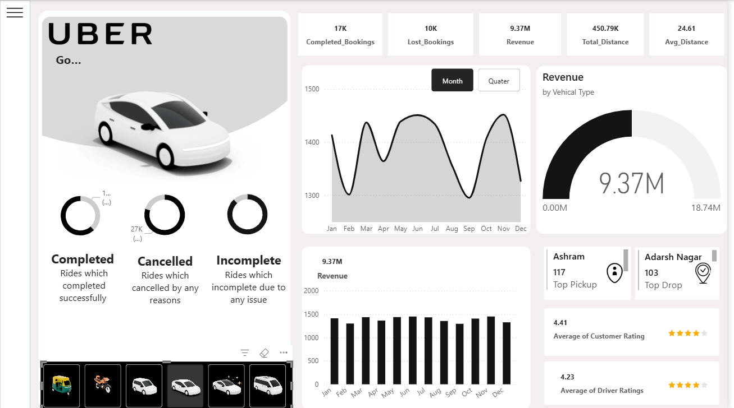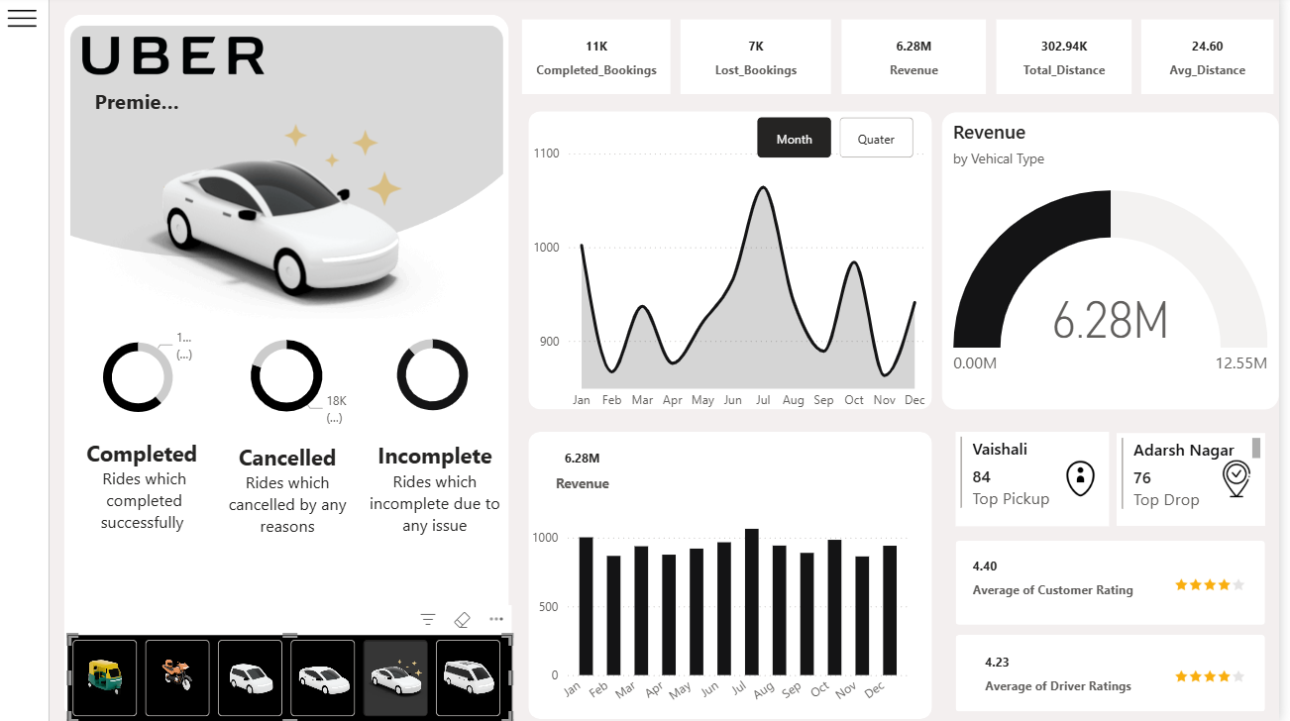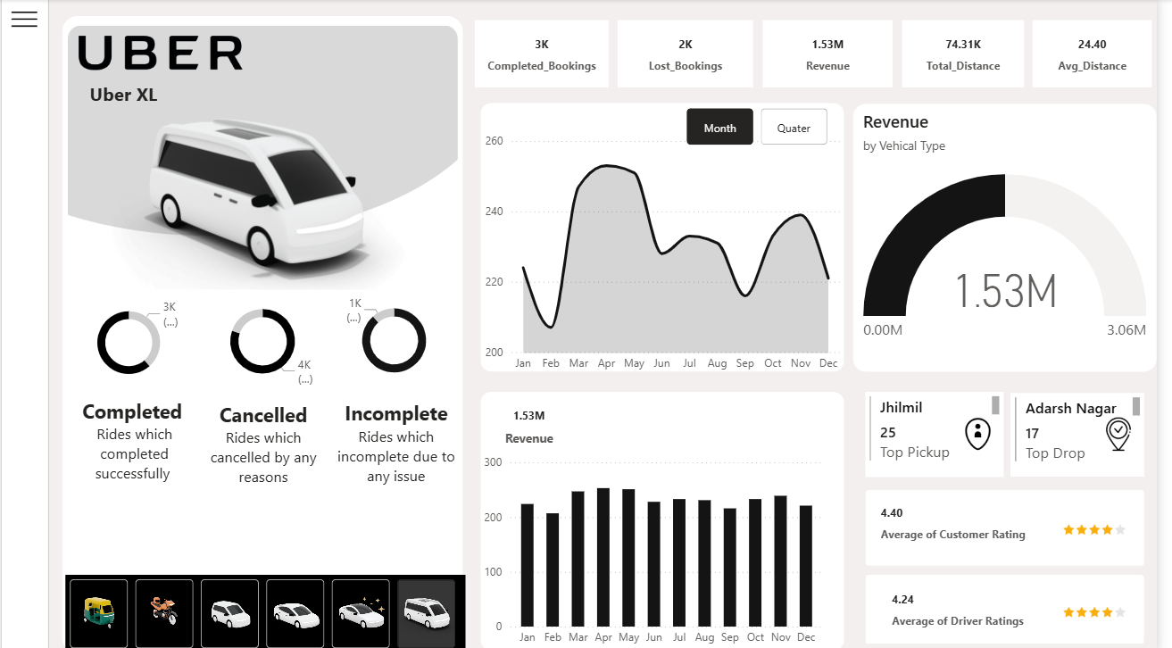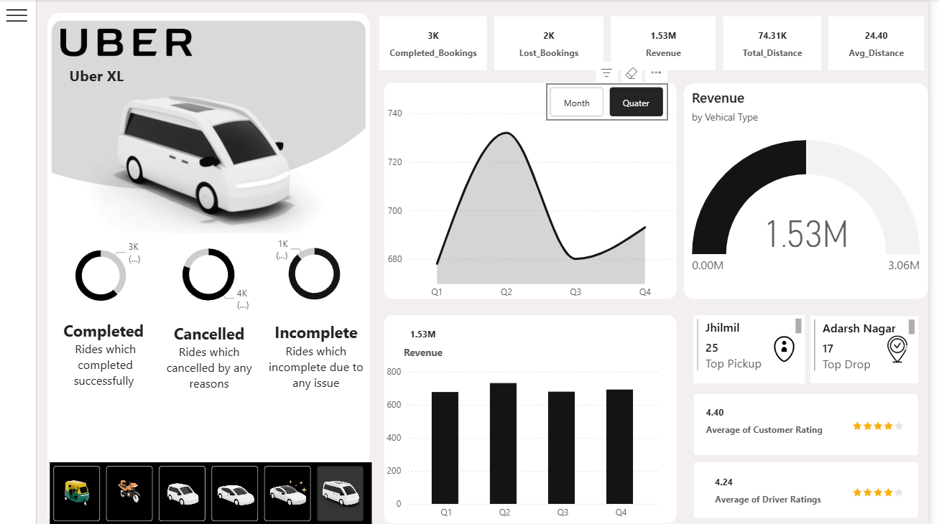

**Dashboard Pages & Insights**

**1. Overview Page**

* KPIs: Completed Bookings, Lost Bookings, Revenue, Total Distance, Average Distance.
* Monthly and Quarterly trend analysis for Bookings and Revenue.
* Revenue by Vehicle Type visualization.
* Top Pickup and Drop Locations based on booking count.
* Average Rider and Driver Ratings display.

**2. Vehicle Page**

* Detailed insights by Vehicle Type.
* Vehicle-wise Booking Count, Revenue, and Contribution.

**3. Revenue Page**

* Revenue analysis by Customer, Vehicle, and Payment Method.
* Monthly and Quarterly Revenue Trends.

**4. Rider Page**

* Ride Cancellation analysis by Reason and Payment Method.
* Categorization of Riders: First-time, Return, and Regular Riders.
* Monthly and Quarterly breakdown with detailed data tables.

**5. Location Page**

* Monthly Total Distance and Vehicle-wise Distance analysis.
* Identification of Busy Areas and Time Slots for demand optimization.

**Features**

* Interactive slicers and filters for dynamic analysis.
* Collapsible Filter Panel for clean visualization space.
* Data modeling using relationships between key tables.
* DAX measures for KPIs like Total Revenue, Avg Distance, and Ratings.

**Tools & Technologies**

* **Power BI Desktop** – Data Visualization & Dashboard Design
* **DAX (Data Analysis Expressions)** – Calculated Measures & KPIs
* **Excel / CSV Dataset** – Source Data
* **Data Cleaning & Modeling** – Power Query Editor

**Key Insights**

* **Premier Sedan** generated the highest revenue share.
* **Vaishali** and **Adarsh Nagar** emerged as the top pickup and drop locations.
* Strong correlation found between completed bookings and customer ratings.
* Busy hours identified for operational scheduling and resource allocation.

**Outcome**

Delivered a fully interactive, business-ready Power BI dashboard providing comprehensive visibility into Uber’s operational performance, enabling better strategic planning and data-driven decisions.